SENSORED BOTTLE

Ahmet Hamza Kozal

Mehmet Akif Sipahi

Abdullah Said Yalchin

When we put water into a flask, we can not see whether it is full or not because of no transparency. With the help of "Flask-sensor", we will understand that our bottle has come to its capacity.

Here is our models:

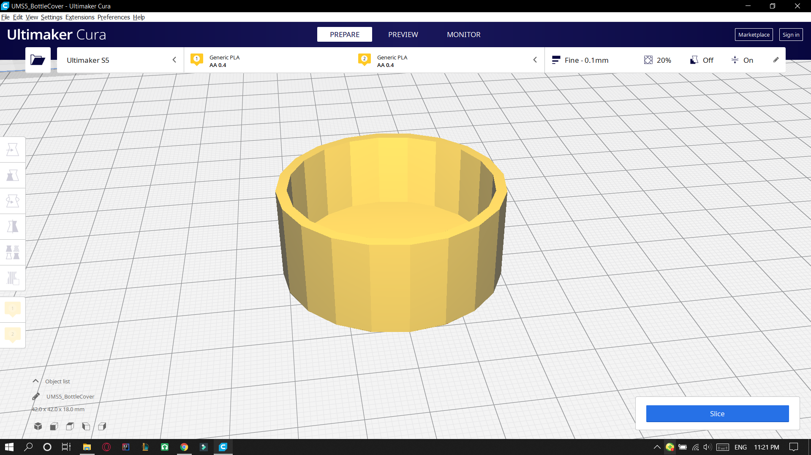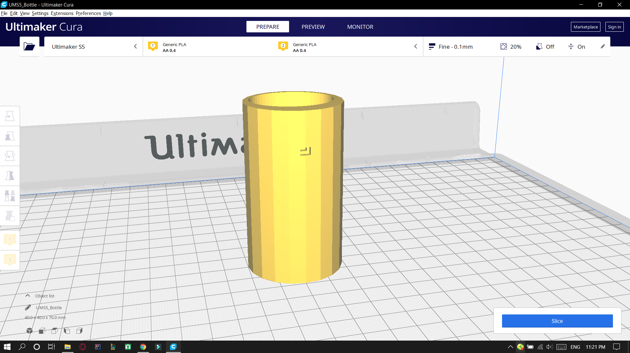

And we planned to add sensor here these little holes:

